EXP#2: Simulation Guidelines

In this experiment, you are going to see how to present a multiple terminal circuit element (more then two terminals, such as BJTs, MOSFETs, OPAMPs etc.) mathematically and how to measure its model parameters. There may be many presentations of the same device that are depen on the selected graph. Each presentation has an accompanying graph. All presentations are equivalent provided that they obey to the graph theory. These mathematical models are particularly useful in circuit simulators such as SPICE and other CAD tools.

First, you are going to select a particular graph. Then, you do the measurements (herein simulation) on the circuit. Finaly, calculate device parameters to present it in matrix form. It is possible to calculate each component’s value, if the conponents’ net is known.

You need to study experiment document first, to get familiar with the subject. You can find all required information in the Lab Manual and references therein (Basics of Electrical Circuits Lab).

The following simulations are done on **LTSpice** platform. To replicate them, you need LTSpice (or a similar one) circuit simulator program (visit **www.analog.com**).

Part List from LTSpice Library

(1) DC Voltage Source: **Vx, AM1, AM2, AM3**

First, search for “cell” in the **Part Tool** search box. Then, place it. Finally, set its parameters:

(2) Resistors: **R1, R2, R3, R4, R5**

First, get a draft resistor from the **Tool Bar**; then right-click on **name** and **value** to set them.

(3) Ground: **GND**

Get a ground element from the **Tool Bar**. Then place it on the net.

(4) Labels: **A, B, C, D**

First, get a draft label from the **Tool Bar**. Then, name it as “A”. Finally, place it on the net.

* Wire up your circuit, then run simulation for **operation point (.op)**.
* To access to measurement results, you need to select **“Pick visible Trace”** from **Tool Bar**, then **Copy** the results therein.

Formulae

**Conductance** of **terminal-m** due to the voltage at **terminal-n** (**Vn** ): **Gmn = Im /Vn** where **Im** is the **terminal-m** current.

(A) T#1 Graph Model Parameters

**Graph T#1: Refer to Fig 2.3** and **Fig 2.4** in Lab Manual

**1**

**2**

**3**

**a**

**b**

**c**

**d**

**Fig.2.1 T#1 Graph**

**Measurement Setup #T1.1:**

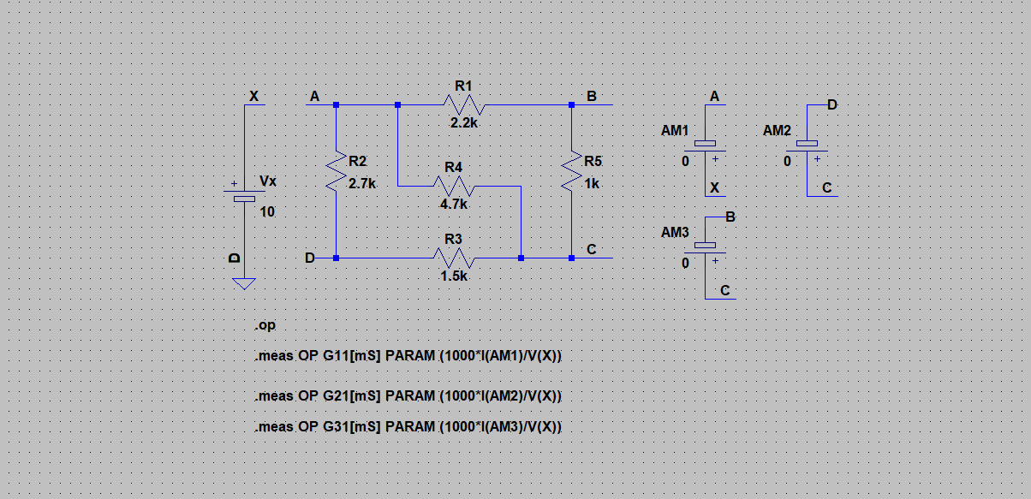

**Report Requirements**

* Include **Operating Point** data after the run or from “Pick Visible Traces” tool bar
* Include measurement **results** from Spice Error Log
* Include **date** and **time** from Spice Error Log

**Measurement Setup #T1.2:**

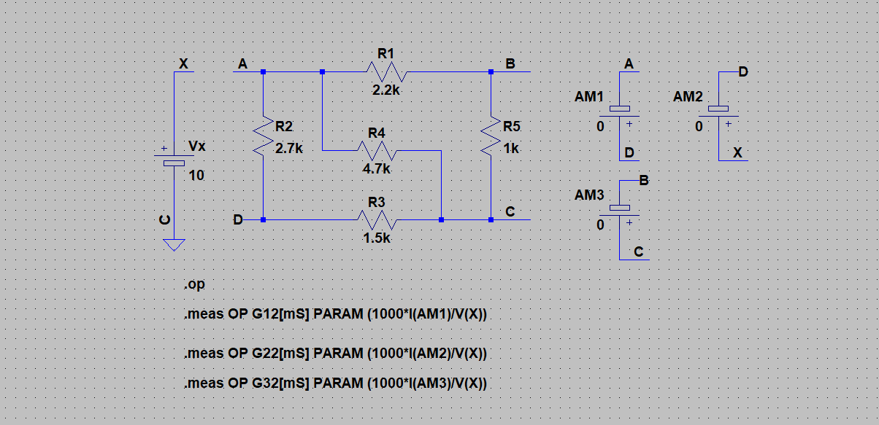

**Report Requirements**

* Include **Operating Point** data after the run or from “Pick Visible Traces” tool bar
* Include measurement **results** from Spice Error Log
* Include **date** and **time** from Spice Error Log

**Measurement Setup #T1.3:**

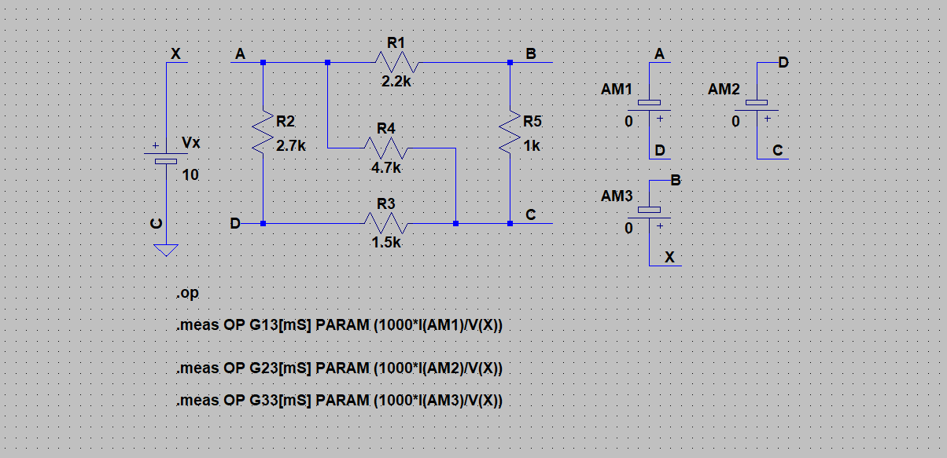

**Report Requirements**

* Include **Operating Point** data after the run or from “Pick Visible Traces” tool bar
* Include measurement **results** from Spice Error Log
* Include **date** and **time** from Spice Error Log
* From all measurements, fill out the following table for each source setting

|  |  |  |  |  |  |
| --- | --- | --- | --- | --- | --- |
| **Table A.1 T1-Graph Measurements** | | | | | |
| **V1 = 10 V, V2 = 0, V3 = 0** | | **V1 = 0 , V2 = 10 V, V3 = 0** | | **V1 = 0 , V2 = 0, V3 = 10 V** | |
| **I1 =** | **G11 =** | **I1 =** | **G12 =** | **I1 =** | **G13 =** |
| **I2 =** | **G21 =** | **I2 =** | **G22 =** | **I2 =** | **G23 =** |
| **I3 =** | **G31 =** | **I3 =** | **G32 =** | **I3 =** | **G33 =** |

* Fill out the following matrix elements from Table A.1to get **[i]=[G][v]** presentation

$$\left[\begin{matrix}i_{1} \\ i_{2} \\ i_{3}\end{matrix}\right]=({10}^{-3})\left[\begin{matrix} & & \\ & & \\ & & \end{matrix}\right]\left[\begin{matrix}v_{1} \\ v_{2} \\ v_{3}\end{matrix}\right]$$

(B) T#2 Graph Model Parameters

**Graph T#2: Refer to Fig 2.5** and **Fig 2.6** in Lab Manual

**2**

**3**

**1**

**a**

**b**

**c**

**d**

**Fig 2.2 T#2 Graph**

**Measurement Setup #T2.1:**

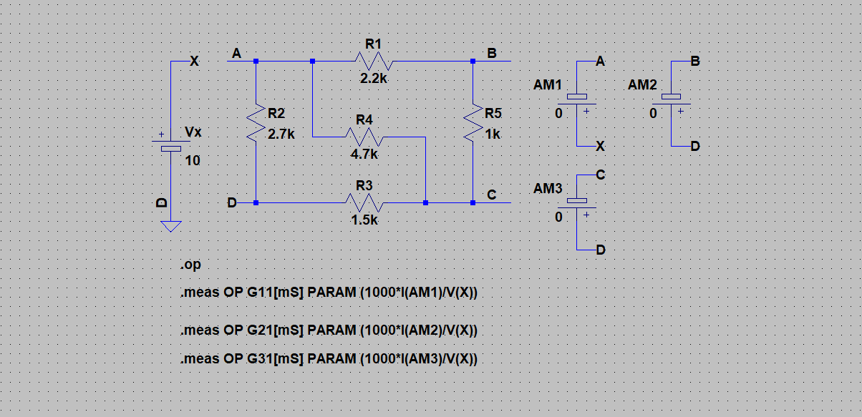

**Report Requirements**

* Include **Operating Point** data after the run or from “Pick Visible Traces” tool bar
* Include measurement **results** from Spice Error Log
* Include **date** and **time** from Spice Error Log

**Measurement Setup #T2.2:**

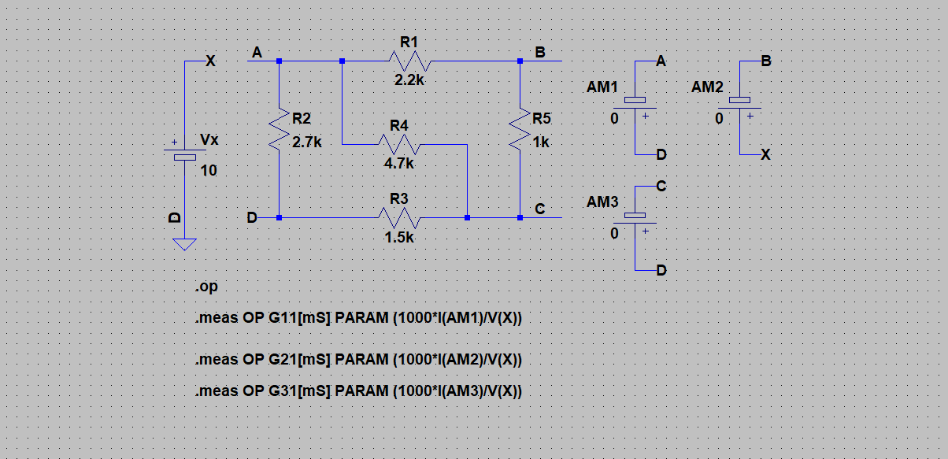

**Report Requirements**

* Include **Operating Point** data after the run or from “Pick Visible Traces” tool bar
* Include measurement **results** from Spice Error Log
* Include **date** and **time** from Spice Error Log

**Measurement Setup #T2.3:**

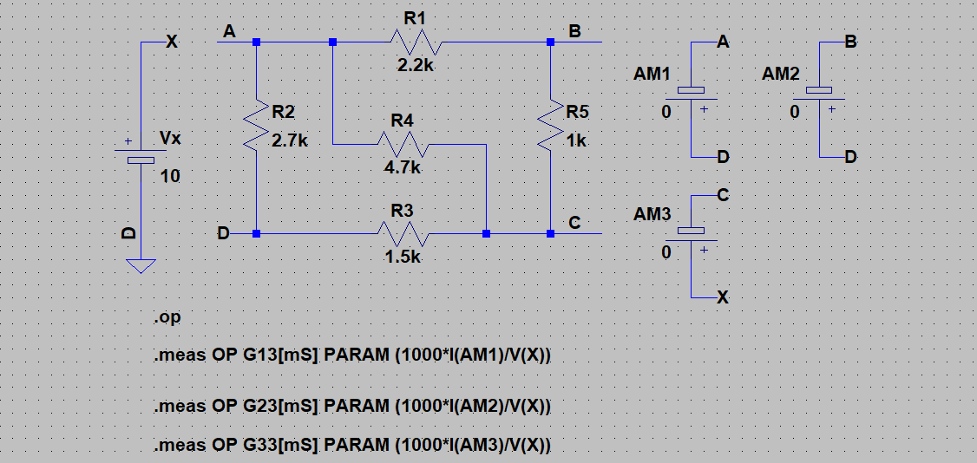

**Report Requirements**

* Include **Operating Point** data after the run or from “Pick Visible Traces” tool bar
* Include measurement **results** from Spice Error Log
* Include **date** and **time** from Spice Error Log
* From all measurements, fill out the following table for each source setting

|  |  |  |  |  |  |
| --- | --- | --- | --- | --- | --- |
| **Table B.1 T2-Graph Measurement** | | | | | |
| **V1 = 10 V, V2 = 0, V3 = 0** | | **V1 = 0 , V2 = 10 V, V3 = 0** | | **V1 = 0 , V2 = 0, V3 = 10 V** | |
| **I1 =** | **G11 =** | **I1 =** | **G12 =** | **I1 =** | **G13 =** |
| **I2 =** | **G21 =** | **I2 =** | **G22 =** | **I2 =** | **G23 =** |
| **I3 =** | **G31 =** | **I3 =** | **G32 =** | **I3 =** | **G33 =** |

* Fill out the following matrix elements from **Table B.1** to get **[i]=[G][v]** presentation

$$\left[\begin{matrix}i_{1} \\ i_{2} \\ i_{3}\end{matrix}\right]=({10}^{-3})\left[\begin{matrix} & & \\ & & \\ & & \end{matrix}\right]\left[\begin{matrix}v_{1} \\ v_{2} \\ v_{3}\end{matrix}\right]$$

(C) T#3 Graph Model Parameters

**Graph T#3: Refer to Fig 2.7** and **Fig 2.8** in Lab Manual

**a**

**b**

**1**

**2**

**c**

**d**

**Fig 2.3 T#3 Graph**

**Measurement Setup #T3.1:**

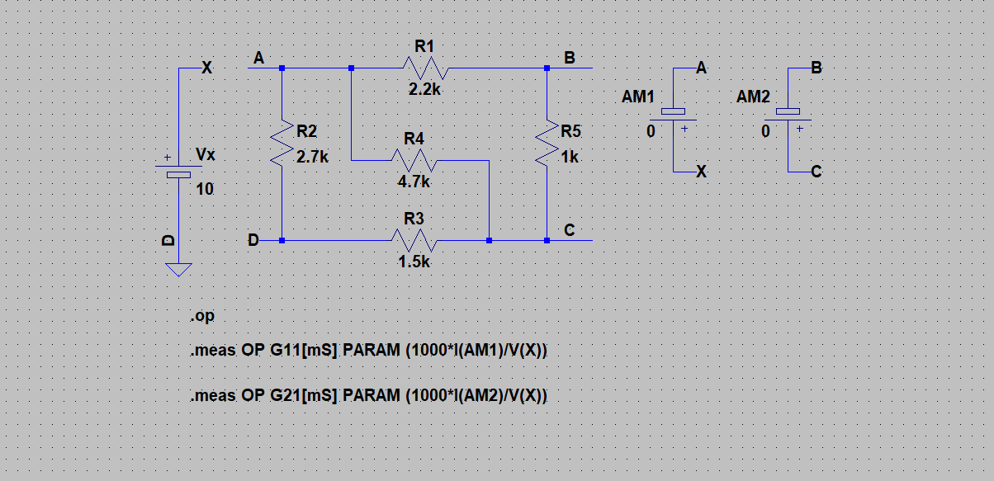

**Report Requirements**

* Include **Operating Point** data after the run or from “Pick Visible Traces” tool bar
* Include measurement **results** from Spice Error Log
* Include **date** and **time** from Spice Error Log

**Measurement Setup #T3.2:**

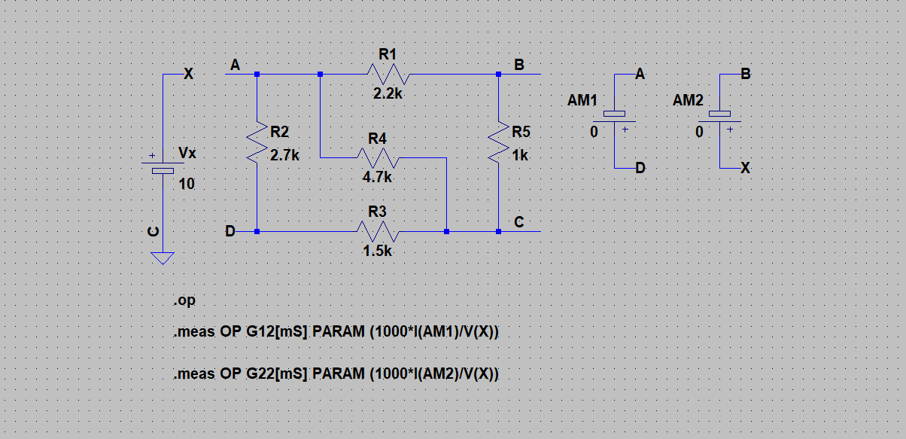

**Report Requirements**

* Include **Operating Point** data after the run or from “Pick Visible Traces” tool bar
* Include measurement **results** from Spice Error Log
* Include **date** and **time** from Spice Error Log
* From all measurements, fill out the following table for each source setting

|  |  |  |  |
| --- | --- | --- | --- |
| **Table C.1 T3-Graph Measurement** | | | |
| **V1 = 10 V, V2 = 0** | | **V1 = 0 , V2 = 10 V** | |
| **I1 =** | **G11 =** | **I1 =** | **G12 =** |
| **I2 =** | **G21 =** | **I2 =** | **G22 =** |

* Fill out the following matrix elements from **Table C.1** to get **[i]=[G][v]** presentation

$$\left[\begin{matrix}i_{1} \\ i_{2}\end{matrix}\right]=({10}^{-3})\left[\begin{matrix} & \\ & \end{matrix}\right]\left[\begin{matrix}v_{1} \\ v_{2}\end{matrix}\right]$$

Please report any error to [ozayan@itu.edu.tr](mailto:ozayan@itu.edu.tr) [R2021.1, AD]